Period 4
Exponential Regression Mini-Project
As our economy continues to grow, our debt is also growing. The purpose of this project is to demonstrate and answer questions about the national debt. We are analyzing the data to answer questions about the past, present, and future of our national debt. As the table shows below, the debt increased every year and is continued to increase.
Good intro
National Debt For 11 Years
Year | Debt  (trillions of dollars)
0 (1980) | .909
1 (1981) | .994
2 (1982) | 1.1
3 (1983) | 1.4
4 (1984) | 1.6
5 (1985) | 1.8
6 (1986) | 2.1
7 (1987) | 2.3
8 (1988) | 2.6
9 (1989) | 2.9
10 (1990) | 3.2
11 (1991) | 3.6
The table below, (diagram #1), shows the national debt from the years 1980-1991. The nation debt increased 2.691 trillion dollars in 11 years.
Diagram #1

Below is the regression equation. In this problem, X=year and Y=Debt.

$$y=.91531693856545(1.137261269485{7)}^{x}$$

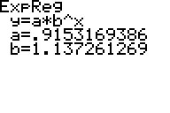

To determine an exponential regression model equation, use the table above. The table above plots the following points. After creating a table in the calculator, graphing the points was
National Debt with Regression Line
National Debt w/out Regression line
Trillions of Dollars
Trillions of Dollars
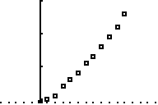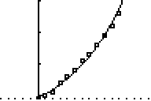
Nicely labeled graphs
Years
Years

Diagram #3 Diagram #4
Diagram #3, shows the graph with the data plotted. Diagram #4 shows the equation with the data points. The line fits very well because it’s going through the middle of the points. As it passes through the points, we can then see how much the debt is increasing each year with each passing point. It doesn’t fit the points exactly, but it follows the shape and trend of the points. Based on this equation, we can then predict what the debt was in 1970, and predict what it will be in 2011.
Good description of why the function is a fit for the data
Original equation:
$y=.91531693856545(1.137261269485{7)}^{x}$
To find out what the debt was in 1970, we must find what we want to put in for X. Looking up at Diagram #1, our table starts at 0, or in years is 1980. 1970, is ten years before 1980. If X is equal to years, then we should put (-10) in for X. By doing this, it shows that we want the value 10 years before 1980, or 0. The equation would then look like:
Nice job of showing the math
$$y=.91531695856546{\left(1.1372612694857\right)}^{-10}$$
This equation says we want to know the value 10 before X, or 0. The value here is: 0.070 trillion dollars.
In order to find how much the debt will be in 2011, we must do the opposite. Instead of subtracting years, you have to add some. The difference between 2011 and 1991 is 20, however; the table starts at 0 and 2011 is 31 years later. The original equation:
$y=.91531693856545(1.137261269485{7)}^{x}$
Therefore we must add 31 years to the table, or plug it into your equation. Now the equation looks like:
$y=.91531695856546(1.1372612694857){X+}^{20}$ $y=.91531695856546{\left(1.1372612694857\right)}^{x+31}$$y=.91531695856546{\left(1.1372612694857\right)}^{31}$
The value here is: 13.634 trillion dollars.
According to forecastchart.com, these numbers are a little off. In 1970, the debt was 0.4 trillion dollars and in 2011, our debt is about 14.34 trillion dollars. One of my predictions is good, while the other is not. For the year 1970, my prediction is .33 off. In 1980, the national debt was at .909 and 0.070 is very low for it being only a ten year difference. For the year 2011, my prediction is very close. The difference between my prediction and the research data is .706.
 | Calculated values | Actual values | Difference in values
1970 | $0.070 trillion | $0.371 trillion | $0.301 trillion
2011 | $13.634 trillion | $14.790 trillion | $1.156 trillion

According to the regression equation, the nation debt should have been 2.5 trillion dollars in late October of 1987. Diagram #5 shows the Y-intercept of when this occurs and diagram #6 shows the graph window used to find the intersection.
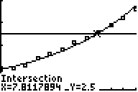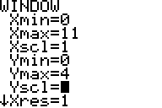
Nice work showing how to find a solution graphically
Diagram #5 Diagram #6
When extrapolating the data, we can find that the national debt was 20 trillion dollars in late November, early December, in 2003. Diagram #7 shows the Y-intercept of when this occurs and diagram #8 shows the graph window used.
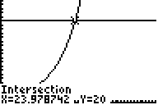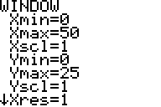
Diagram #7 Diagram #8
When we’re talking about big numbers, and how much it actually is, we don’t really visualize what exactly that means. Or how big of a difference a million, a billion, and a trillion are together. 1 million seconds is 12 days. 1 billion seconds is 32 years. 1 trillion seconds is 32,000 years. Huge differences between those 3 numbers. A trillion dollars is a 1 with 12 zeros after it. But just how much is this in real world terms? If a jet was flying at the speed of light, and had dollar bills trailing after it, it would take 14 years or traveling before the jet ran out of money. Our national debt is gradually growing as the years continue, and if it continues, who knows what the debt will be in 2020.

